


MSc. Computer Engineering, Cybersecurity and Artificial Intelligence

Fraud Detection using Random Forest

Prepared by
Mohamed NJAH
70/90/00524

Table of contents
I. Introduction 5
II. Motivation and state of the art 6
III. Dataset 6
IV. Methodology 7
1. Data Preprocessing 7
2. SOM Training 9
3. Neuron Labeling and Testing 11
4. Evaluation Metrics 12
V. Results 13
VI. Conclusion 16

Introduction
The global transition toward digital payments has transformed commerce, according to the latest joint report by the European Banking Authority (EBA) and the European Central Bank (ECB), payment fraud across the European Economic Area (EEA) reached €4.2 billion in 2024, up from €3.5 billion in 2023.
Historically, financial institutions relied on rule-based systems, simple heuristics such as "flag transactions over $500" or "block purchases from high-risk countries." While these approaches caught obvious fraud, they suffered from critical limitations:
- High false positive rates: for every actual fraud case, rule-based systems flag many legitimate transactions, frustrating customers and costing merchants sales.
- Inability to adapt: fraudsters continuously evolve their tactics, but rule-based systems require manual updates, creating persistent windows of vulnerability.
- Missed complex patterns: sophisticated fraud schemes involve subtle correlations across multiple variables that simple rules cannot capture.
These limitations have driven the financial industry toward machine learning. Unlike static rules, ML models can identify complex, non-linear patterns, adapt automatically to emerging fraud trends, and reduce false positives while maintaining high detection accuracy.
This report will study the applicability of the Random Forest algorithm to solve fraud detection using the IEEE-CIS Fraud Detection

Motivation and state of the art
The growing sophistication of fraudulent transactions demands detection systems that go beyond simple rule‑based heuristics. Machine learning offers a pathway to automatically learn complex patterns from historical data, adapt to evolving fraud strategies, and flag suspicious activities in real time.
Several previous studies have demonstrated the effectiveness of Random Forest for fraud detection. For instance, Bhattacharyya et al. (2011) compared Random Forest with support vector machines and logistic regression on a real‑world credit card dataset, concluding that Random Forest achieved superior predictive performance while maintaining reasonable computational efficiency. More recently, Xuan et al. (2018) applied a Random Forest model to a Chinese bank's transaction data, reporting high accuracy and low false positive rates, and noting the algorithm's resilience to class imbalance when combined with resampling techniques.
Despite these successes, the application of Random Forest to fraud detection is not without challenges. The severe class imbalance (fraud often accounts for less than 5% of transactions) can bias the model toward the majority class, necessitating careful handling through sampling techniques.

Dataset
The IEEE‑CIS Fraud Detection dataset, released for a Kaggle competition by IEEE in collaboration with Vesta, is designed to mirror the complexity of real‑world financial transactions. It consists of two tables, transaction and identity, linked by a unique TransactionID. Not all transactions have corresponding identity information, reflecting the incomplete data often encountered in production environments.

The transaction table contains 394 features describing the payment event itself. These include TransactionAMT (payment amount in USD), TransactionDT (a timedelta from a reference datetime, not an actual timestamp for privacy), and ProductCD (product code). Payment card information (card1 to card6), address details (addr1, addr2, dist), email domains (P_emaildomain, R_emaildomain), and various masked features such as counting variables (C1 to C14), timedeltas (D1 to D15), and match indicators (M1 to M9) are also provided. The Vxxx features are rich, anonymised variables engineered by Vesta's fraud detection system, including rankings, counts, and entity relations.

The identity table captures the digital context of each transaction, including network information (IP, ISP, proxy) and digital signature details (browser, operating system, device model). These features (id_12–id_38, DeviceType, DeviceInfo) are categorical and masked to protect privacy and honor contractual agreements with data partners.

The data is provided in four files: train_transaction.csv, train_identity.csv, test_transaction.csv, and test_identity.csv. The training set includes the binary target isFraud (1 for fraudulent, 0 otherwise), while the test set requires participants to predict fraud probabilities. The dataset is severely imbalanced, reflecting the rarity of fraud in real payment systems.

Methodology
Our methodology comprises several stages, from data preprocessing to model training and evaluation. The following steps outline our approach:

Data Preprocessing
- Data Cleaning: We begin by importing the dataset and removing non-numeric columns (such as URL, domain, and title) that do not directly contribute to numerical analysis.
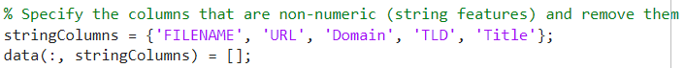
Figure 3 Removal of non-numeric columns
- Feature Reduction: Redundant features are eliminated. For instance, DomainTitleMatchScore is removed due to its high correlation with URLMatchScore.
Figure 4 removal of DomainTitleMatch
- Splitting: The dataset is split into training (80%) and testing (20%) sets to prevent data leakage.
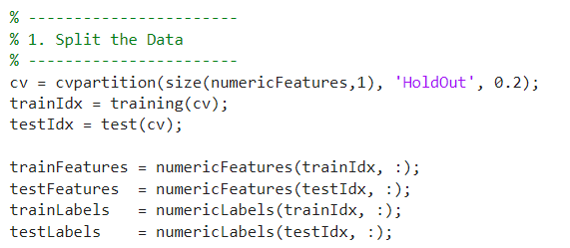
Figure 5 Dataset split
- Normalization: Training features are normalized using z-score normalization, the same parameters are applied to the test set.
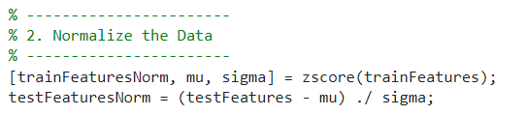
Figure 6 Data normalization

Random Forest Training
- Self-Organizing Maps: A self-organizing map (SOM) or self-organizing feature map (SOFM) is an unsupervised machine learning technique used to produce a low-dimensional (typically two-dimensional) representation of a higher-dimensional data set while preserving the topological structure of the data.
The following figure shows the learning steps:

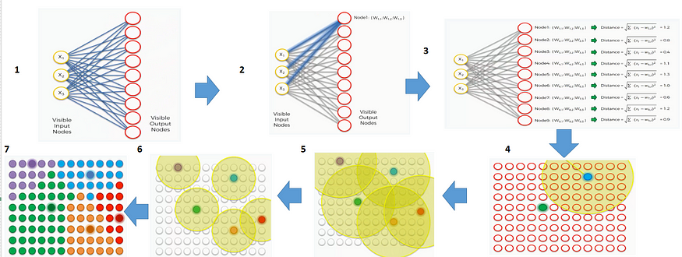
Figure 7 SOM Steps

- SOM Configuration: A 3×3 SOM grid is selected, providing 9 neurons that map the high-dimensional data into a two-dimensional space, the number of epochs for the learning phase is 200.

- Training Process: The SOM is trained using the normalized training data. During training, each input vector is mapped to its Best Matching Unit (BMU), and weight updates are performed based on a neighborhood function.

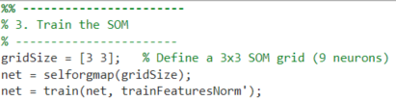
Figure 8 SOM training script

Model Evaluation
- Label Assignment: For each neuron, a label is assigned by majority voting from the training samples that are mapped to that neuron.
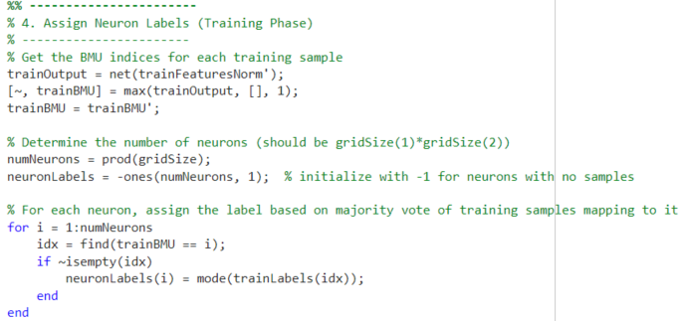
Figure 9 Neuron labels assignment
- Testing Phase: Test samples are then fed through the trained SOM. The BMU for each test sample is determined, and the neuron’s label is used as the prediction.
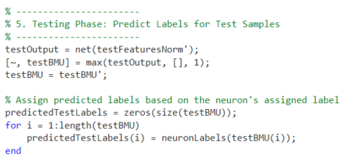
Figure 10 Label prediction for test samples

Evaluation Metrics
- Accuracy: The overall classification accuracy is calculated.
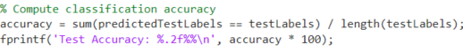
Figure 11 Computing accuracy
- Confusion Matrix: A confusion matrix is generated to illustrate the model’s performance.
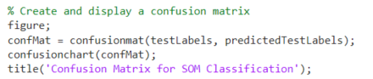
Figure 12 Creating the confusion matrix
- Additional Metrics: Per-class precision, recall, F1 score, and specificity are computed, along with macro-averaged metrics. These metrics provide a detailed understanding of the model’s performance across different classes.
The methodology leverages the strengths of SOM for both visualization and clustering, while comprehensive evaluation ensures that the model’s classification ability is critically examined.

Results
The results of our study are presented in several parts:
SOM Visualization
- Hits Map: A hits map (plotsomhits) shows the number of training samples mapped to each neuron, indicating data density and cluster activity.
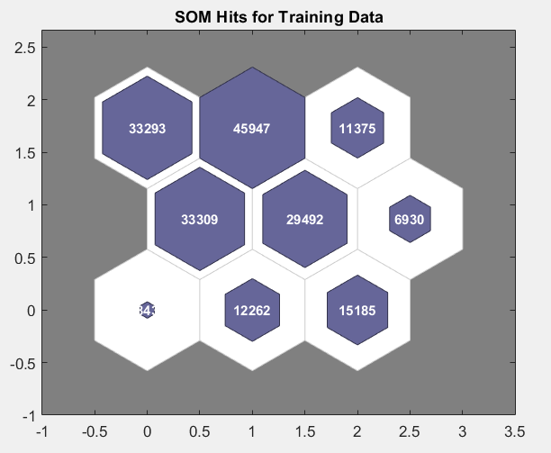
Figure 13 SOM hits map
- Weight Planes: The weight planes (plotsomplanes) provide insight into how individual features are distributed across the SOM grid.
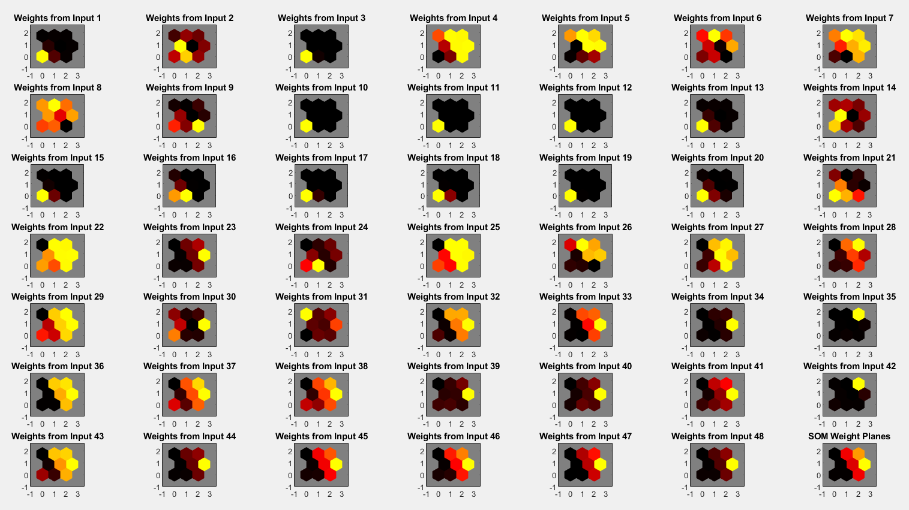
Figure 14 SOM Weights
Classification Performance
- Overall Accuracy: Our SOM classifier achieved an accuracy of approximately 99.11% on the test set.
- Confusion Matrix: The confusion matrix reveals the distribution of correct and incorrect classifications, showing how well the model distinguishes between phishing and non-phishing URLs.
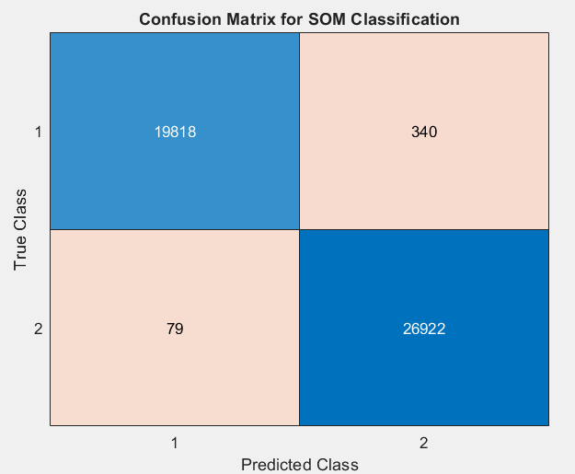
Figure 15 Confusion matrix
Evaluation Metrics
For each class, the following metrics were calculated:
- Precision: The ratio of true positives to the sum of true and false positives.
- Recall: The ratio of true positives to the sum of true positives and false negatives.
- F1 Score: The harmonic mean of precision and recall.
- Specificity: The proportion of true negatives correctly identified.
Macro-averaged metrics, calculated as the mean of the per-class metrics, provide an overall performance indicator.

Figure 16 Evaluation metrics

Conclusion
In conclusion, this study demonstrates the applicability of Self-Organizing Maps in classifying phishing URLs. The unsupervised nature of SOM enables effective clustering and visualization of high-dimensional URL features, thereby highlighting underlying patterns in the data. Our methodology—from data cleaning and normalization to SOM training and comprehensive evaluation—offers a robust framework for phishing detection.
Key takeaways include:
- Effectiveness of SOM: The SOM successfully grouped similar URLs, providing both a visual and quantitative basis for phishing detection.
- Evaluation Insights: While the overall accuracy is promising, detailed evaluation metrics (precision, recall, F1 score, specificity) reveal areas where the model may require further refinement.
- Future Directions: Future work could explore advanced feature engineering, the integration of dimensionality reduction techniques (such as PCA), and the combination of SOM with other classification models to enhance performance.
Overall, this work contributes to the growing body of research on machine learning-based phishing detection, offering insights that could help develop more sophisticated, adaptive security systems.

Joint EBA-ECB report on payment fraud
Bhattacharyya, S., Jha, S., Tharakunnel, K., & Westland, J. C. (2011). Data mining for credit card fraud: A comparative study. Decision Support Systems, 50(3), 602–613.
Xuan, S., Liu, G., Li, Z., Zheng, L., Wang, S., & Jiang, C. (2018). Random forest for credit card fraud detection. In 2018 IEEE 15th International Conference on Networking, Sensing and Control (ICNSC), 1–6.
IEEE-CIS Fraud Detection Dataset
A Beginner's Guide to Self Organizing Map (SOM) - Link

